Andrew Jackson:
B.A.M.F. With Attitude

By John Scovic

Overview:
Andrew Jackson: B.A.M.F. With Attitude is an exaggerated, supernatural, and goofy account of the 7th President’s ascendance to the presidency, as well as his time in office. While the timeline of events and the events themselves are based on actual historical records of Jackson, it also includes vampires and velociraptors and jetpacks, as well as a fictional story involving a country-wide conspiracy against Jackson, led by Henry Clay. The game functions in many different ways, with different gameplay styles and goals associated with different levels. The core gameplay will remain a top-down brawler of sorts, but weapons, enemies, and objectives will be constantly changing as the game progresses.

Story:
The Game opens up on Andrew Jackson in the Battle of New Orleans. This was the first major point of his career, because his actions in this battle are what earned him his War Hero respect and eventually the presidency. Rather than a traditional siege-style colonial-era battle, though, the battle would mostly consist of Jackson running around from British soldier to British soldier, attacking them with his beating stick, “Old Hickory.” There would be 3 “bosses,” or high-ranking British officers, and killing all of them before your soldiers are defeated will win the level.
After this battle and some post-level exposition, the next level will consist of Andrew Jackson with a modern-day rocket launcher, blowing up teepees full of Native Americans. Jackson was widely known to dislike them very greatly, and took every opportunity he could find to fight and kill them. The level is complete once all of the houses are destroyed.
After the early focus on Jackson’s military career, the next part would focus on the election of 1824, Jackson’s first bid for office. This part of the game would consist of a footrace with John Quincy Adams, representative of the real life presidential race. To represent the “corrupt bargain” of Adams and Clay that caused them to win out over Jackson despite of his popular vote dominance, Clay will frequently intervene in the race and make it harder for Jackson to come out on top. After the player avoids obstacles and hazards to try to keep up with Adams, at the last second Henry Clay sticks out his long scaly tail to trip Jackson. This is the first hint that Henry Clay is secretly a velociraptor, a point that will become more integral to the story later on.
Following the 1824 election, Jackson runs again in 1828. His running mate is Martin Van Buren, who can shoot his sideburns off to attack foes. This next section will be a large-scale fight between Jackson supporters and Adams supporters, in which Jackson commands Van Buren to participate. The player controls Van Buren, using his rocket sideburns and martial arts to defeat the Adams supporters and win Jackson the presidency. Martin has a climactic battle with Adams at the end, who says “You may have defeated me, but you’ll never stop Clay!” This reveals that Adams was just a part of something bigger.
The first major event of Jackson’s presidency is the Bank War. Jackson and his supporters fight a large-scale war against enemies made of coins and bills. For this level, Jackson rides in a USA-themed motorcycle, equipped with a flamethrower on the front to burn the money. Jackson rides the motorcycle through the Bank troops on his way to the National Bank, where he plants a bomb. As the bomb is ticking down, Henry Clay and his goons walk into the Bank. Clay gives a speech about how the Bank is only the beginning to taking over the USA and its money, and tells Jackson he can’t stop what is already set into motion.
Clay’s goons tear off their skin and reveal themselves to be velociraptors, who then engage in a fight with Andrew Jackson. Clay slinks off, laughing. The player has to once again use his trusty Hickory stick to fight off the enemies, and has a time limit to do so. The enemies must be defeated before the bomb runs out, so that Jackson has enough time to get back on his motorcycle and ride away as the bank explodes.
When Jackson returns to the White House, he is ambushed by more of Clay’s men in an assassination attempt. Being the B.A.M.F. that he is, Jackson turns this attempt on them. He pulls the cover off of “Old Hickory,” revealing its true form, a giant Katana that he then uses to fight the assassins. Once they are defeated, he realizes he can’t live like this any longer. He decides to take the fight to Clay to see just what it is that he is after. When he reaches Clay’s office, he realizes that Clay was expecting him.
Clay goes into his villain monologue, explaining that his plan to take over the USA actually involves launching a space station to rule over the country in from afar. Clay reveals his true form by taking off his human mask, and he too is a giant velociraptor, named Henry Claw. Claw explains that Jackson is already too late, and he can’t stop the station from being launched. Claw pushes Jackson out the door and closes it, and the room detaches itself from the building and starts flying into space.
Jackson quickly returns to the White House and pulls out his secret weapon- Space Force 1. He and Van Buren take the small starfighter up into the sky and engage in aerial combat with Claw’s velociraptor ships. Eventually Jackson reaches Claw’s ship and lands on it, telling Van Buren to stay and protect the ship. Once again taking to his Katana, Jackson fights his way to Claw’s quarters for the final fight. Claw immediately knocks the Katana away and makes Jackson fight him man-to-dinosaur. Just when it seems like Jackson will be defeated, Van Buren comes in and shoots a rocket sideburn at Claw as a distraction. This moment of hesitation gives Jackson the opening he needs to attack, and he defeats Claw with his fists alone. The final blow is so powerful, it sends Claw hurtling through the glass windshield of the space station. The glass shatters and emergency lights flash everywhere. Jackson and Van Buren return to the ship, only to find that velociraptors have destroyed it in their absence.
Quickly determining another method of escape from the failing space station, Jackson and Van Buren don Power Space Suits, with fully functional jetpacks, that they find and dive headfirst out of the nearest window. As the two jetpack back to earth, the station explodes, taking all of the remaining velociraptors with it. The station, no longer able to sustain itself, crashes to the earth, right on top of the nearest Indian Reservation. Jackson, not ready to tell the public about what he did to save them, takes the blame for destroying the Indians’ homes and forces them to move elsewhere, leading to The Trail of Tears incident.
While public opinion of him will only go down over the years, Jackson and Van Buren know what they did to save the USA from the clawed menace.

Level Structure:
-1. Battle of New Orleans
-First cutscene: Opens on Jackson fighting British, introduces him as the main character
-Goal: defeat the 3 British leaders to complete the level
-End cutscene: Jackson receives a medal for his service
-2. Native American rocket launcher level
-First cutscene: Jackson beating Natives, pulls out a rocket launcher because it is “taking too long”
-Goal: destroy all huts
-End cutscene: “This is boring. I should run for President instead.”
-3. Race of 1824/Corrupt Bargain
-First cutscene: starting line, establishes Adams and Jackson are racing
-Goal: get to the finish, avoiding obstacles laid by Clay.
-End Cutscene: Jackson trips on Clay’s tail and loses to race.
-4. Election of 1824
-First cutscene: establishes Van Buren as a running mate
-Goal: defeat all Adams supporters as Van Buren
-End cutscene: Jackson wins the election
-5. Bank War
-First cutscene: “This bank is corrupt! It’s trying to take the citizens’ money!” Jackson gets on his motorcycle
-Goal: get to the National Bank by driving through the coin men
-End cutscene: Jackson parks outside and enters the bank
-6. Inside Bank Fight
-First cutscene: Clay and his men walk in, and take their masks off the reveal their dinosaur selves
-Goal: defeat all enemies
-End cutscene: Clay runs away and Jackson drives away as the Bank explodes
-7. Assassination Attempt
-First cutscene: Clay’s men ambush Jackson at the White House, turn into velociraptors
-Goal: defeat all assassins
-End cutscene: Jackson says he needs to take the fight to Clay
-8. Claw’s Office
-First cutscene: Jackson walks into Clay’s office, Clay explains his plan and reveals he is actually a velociraptor named Claw
-End cutscene: Claw kicks Jackson out of his office and the office detaches itself from the building, flying into space
-9. Space Force 1 Dogfight
-First cutscene: Jackson returns to the White House and he and Van Buren get in the presidential spaceship, launching it into space.
-Goal: fight through the Velociraptor spaceships and make it to Claw’s space station
-End cutscene: land on the space station and tell Van Buren to wait there
-10. Space Station
-First cutscene: Jackson exits the spaceship and fights his way through the velociraptors on the station.
-Goal: make it to the main room of the station
-End cutscene: Jackson opens the door and walks into Claw’s office
-11. Final Fight with Claw
-First cutscene: Claw is initially beating Jackson in the fight, but Van Buren runs in and distracts Claw
-Goal: Defeat Claw, knocking him into space
-End cutscene: the station goes into meltdown, with emergency sirens and lights everywhere
-12. Jetpack Escape
-First cutscene: Jackson and Van Buren find their ship destroyed, and have to find another way off the station in the form of power suits with jetpacks
-Goal: fly away from the exploding station, avoiding falling debris
-End cutscene: the station destroys a native American settlement as it crashes to the earth
-13. Conclusion
-First cutscene: Jackson takes responsibility for the destroyed settlement, hiding the truth from the public
-End cutscene: The narrator says that Jackson will always be a hero, even if he won’t be remembered that way by most.

Characters:
Andrew Jackson: The main character. He is brash, tough, and aggressive. He acts based on impulse rather that rational thought and logic, which caused him to be such a great military mind. He fights using his beating cane, “Old Hickory,” which is later revealed to be a hidden sword. He occasionally uses vehicles like the Presidential Motorcycle and the Presidential Spaceship to fight his enemies, as well as unarmed combat.
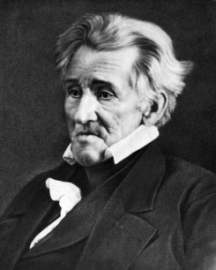
Martin Van Buren: Jackson’s running mate and best friend, Van Buren is quieter and more soft-spoken than the brash and impulsive Jackson. He fights by shooting off his rocket-powered sideburns, and by using martial arts. He is also Jackson’s official driver when he needs to ride in the Presidential Spaceship, Space Force 1.
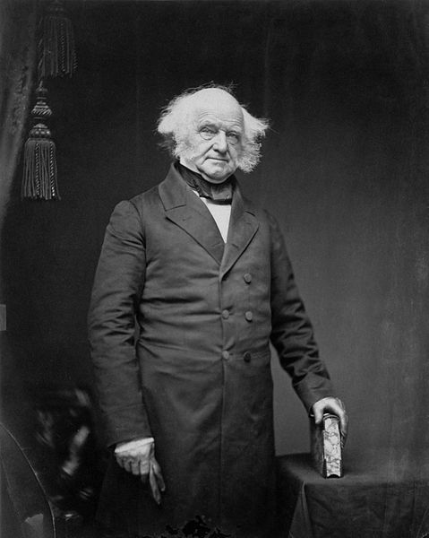
John Quincy Adams: An old, bumbling man who doesn’t seem to know what he’s doing but somehow beats Jackson in the 1824 election. Works for Henry Clay, and prefers to let his lackeys do the fighting for him. Not much of a thinker or a combatant, JQA is just a part of something larger.
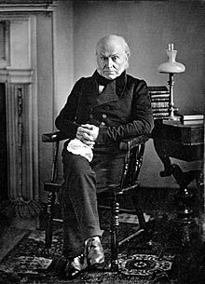

Henry Clay (Henry Claw): The shadowy leader of the Velociraptor organization, he is a master tactician as well as a powerful physical opponent. He himself is a velociraptor, and isn’t against using his true from to carry out his plans for taking over the USA. He fights by sending his army of underlings wherever they are needed, and also by fighting for himself with tooth and claw.
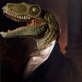

Time Management:
Day 1: character sprites/animation
Day 2: Andrew Jackson regular control scheme, stick/sword combat
Day 3: Andrew Jackson regular control scheme, stick/sword combat
Day 4: Auxiliary control schemes (vehicles, Van Buren)
Day 5: Auxiliary control schemes (vehicles, Van Buren)
Day 6: Enemy AI and attacking
Day 7: Background Sprites/cutscenes
Day 8: Background Sprites/cutscenes
Day 9: Menus/overlays
Days 10-14: Bug-fixing/polish

List of Character Sprites:
Andrew Jackson:
Walk cycle, attack with stick, attack with sword, death, cutscenes
Van Buren:
Walk cycle, attack with sideburns, attack with martial arts, death, cutscenes
Clay:
Human walk cycle, velociraptor walk cycle, human attack, velociraptor attack, transform, cutscenes
Adams:
Walk cycle, attack, death, cutscenes
British enemies/British leaders:
Walk cycle, shoot, death
Native Americans:
Walk cycle, death, attack, cutscenes
Bank Enemies:
Walk cycle, attack, death, cutscenes
Jackson motorcycle:
Drive, flamethrower, death, cutscenes
Space Force 1:
Fly, shoot, death, cutscenes
Velociraptor ships:
Fly, shoot, death, cutscenes
Jackson/Van Buren power suits
Fly, death, cutscenes

Menus and Overlays:
Health readout
Lives readout
On-screen text
Objective indicators
Start menu/level select
Controls:
WASD to move Jackson/Van Buren/motorcycle/spaceship
Spacebar to attack with stick/sword/sideburns/motorcycle flamethrower/spaceship lasers/rocket launcher
Enter to attack with fists/martial arts

